# Process for connecting to and programming the NichDrop:

1. Make sure the NichDrop has power and that the three USART lines are connected correctly (Tx, Rx, Gnd).
2. Open NichDropTester.exe

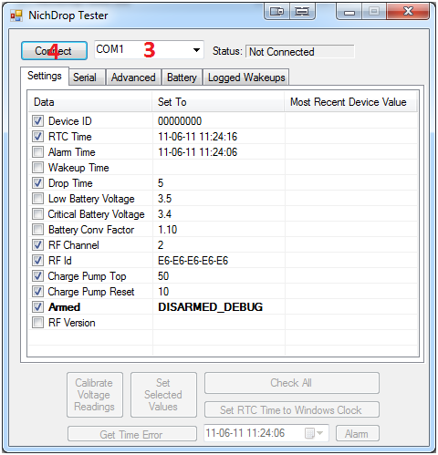

1. Select the appropriate COM port.
2. Click “Connect”

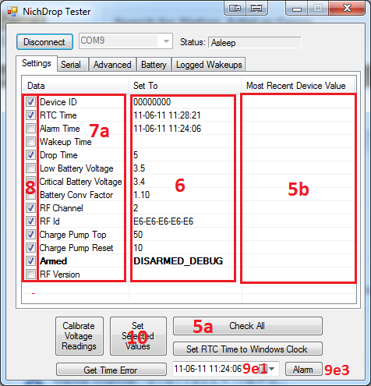

1. To read data from the connected NichDrop
   1. Click “Check All”
   2. The results from the device will be displayed here (5b)
2. The values in the “Set To” column are the values to write to the NichDrop.
3. To change these values,
   1. double click on the corresponding item in the data column (the text, not the check box)
   2. and enter the new value in the text box that appears.
   3. Note that some items cannot be changed.

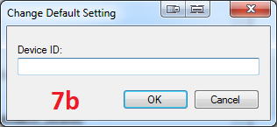

1. Not all values will be written to the NichDrop, only the ones whose check boxes are checked will actually be programmed to the NichDrop.
   1. Do not reprogram the following unless you know what you are doing: “Low Battery Voltage”, “Critical Battery Voltage”, “Battery Conv Factor”.



1. The most important values to set are:
   1. “RTC Time”: This is automatically set to the windows clock time on the progtamming computer if checked.
   2. “Drop Time”: Should be 5 seconds.
   3. “Device ID”: An identifying number for the NichDrop.
   4. “Armed”: NEEDS TO BE SET TO “ARMED”. If it is not then the device will not actually fire!
   5. “Alarm Time”: Should be set to the time when the device is to drop off.
      1. Is chosen using the date-time picker (9e1)
      2. Can be set by making sure its check box is set when programming selected values
      3. Can also be set by clicking “Alarm” (9e3)
2. To program the values to the NichDrop, click “Set Selected Values”
3. After programming the values, always click “Check All” again and ensure that the new values on the device match the ones you wanted programmed.
   1. Pay special attention to the “Armed” value, there is a bug the causes it to be programmed incorrectly sometimes. It will always show the REAL value on the device after clicking “Check All”.